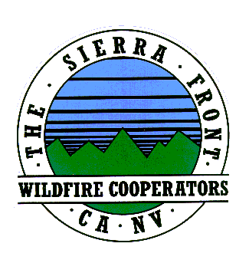
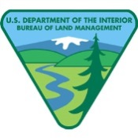
Announcement
Nate Rasner Sierra Front Type 3 Team
Mark Regan
Public Information Officer
Phone: 760-647-6472
Walkerfire2015@gmail.com
August 20, 2015 Announcement #4, 8 a.m.

Date Started: 8/14/2015  Cause: Human | Total Personnel: 477  Injuries/Illnesses to Date:0
Size: 3,715 acres | Structures Threatened: 235
Percent Contained: 45%  Resources: 3 helicopters, 0 seats, 0 Air tankers  34 Engines, 10 Crews, 6, Water Tenders, 4 Dozers | Structures Lost: 0  Estimated Containment:8/23/2015

Code Red Emergency Alert Has Been Lifted

Lee Vining, CA: The Code Red Emergency Alert notice issued for Lee Vining and everything north of Double Eagle in June Lake (including Silver Lake and Grant Lake areas) for potential evacuations has been lifted.

Campgrounds in the Lower Lee Vining Canyon will remain closed through the weekend.
These areas include: Lower Lee Vining, Moraine, Boulder, Aspen Grove and Big Bend campgrounds.

###

