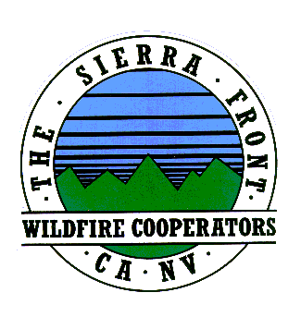
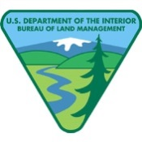
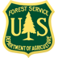
News Release
Nate Rasner Sierra Front Type 3 Team
Mark Regan
Public Information Officer
Phone: 760-647-6472
Walkerfire2015@gmail.com
August 21, 2015, Update #10 8:00 p.m.

Date Started: 8/14/2015  Cause: Human | Total Personnel: 382  Injuries/Illnesses to Date: 3
Size: 3,676 acres | Structures Threatened: 220
Percent Contained: 60%  Resources: 1 Helicopters, 0 Seats, 0 Air Tankers  29, Engines, 8 Crews, 6 Water Tenders, 2 Dozers | Structures Lost: 0  Estimated Containment: 8/23/2015
Walker Fire is at 60% Containment
Lee Vining, CA: Burning approximately two miles southwest of Lee Vining the Walker Fire remains at
3,676 acres. This is a human-caused fire that is still under investigation.

Smoke in the area is the result of several wildfires burning throughout California. Despite high winds, crews made considerable progress improving containment lines as well as mop up, which includes extinguishing hot spots to ensure that the fire does not re-ignite.

Tioga Pass (Highway120) is open without restrictions and the Code Red Emergency Alert notice issued
for June Lake has been lifted. Campers who were evacuated are asked to call for an escort to go back
into the campground to retrieve their belongings as soon as possible. Please call 760-647-6472 to
make arrangements.

Anyone who was in the Walker Lake area on August 14, 2015, is asked to call 760-920-7149 with any information that may pertain to the fire.

The fire is burning in mixed conifer, mahogany, and brush. Critical sage grouse habitat is also threatened. Visitors and residents should expect to see smoke from the June Lake and Lee Vining areas and along Highway 395. This will be the last evening update for the Walker Fire.

For the safety of our firefighters, effective air operations and continued containment efforts, please keep drones away from the Walker Fire and near heliports.
Closures and Evacuations:
- Walker Lake “Fishing Camp” has been evacuated.
- Campgrounds in the Lower Lee Vining Canyon have been evacuated and will remain closed through the weekend. These areas include Lower Lee Vining, Moraine, Boulder, Aspen Grove, and Big Bend Campgrounds.
- PLEASE NOTE: The Walker Lake Road (1N17), the Parker Lake Rd. (1S25), the Upper Horse Meadows Rd. (1N16), and the Gibbs Road (1N18) are closed for fire operations and public safety. All of these roads are accessed via the northern end of the June Lake Loop. All spur roads off of these roads are also closed. The trail to Mono Pass (trailhead is at Walker Lake) is closed.
Approximately 382 firefighters are on scene as well as numerous aircraft, dozers, and engines. Resources from Mono County, local fire departments, Cal Fire, neighboring forests, BLM Bishop Field Office, and the Mono County Sheriff’s Office are assigned. For more information on the Walker Fire you can go to the following sites: Inciweb: http://inciweb.nwcg.gov/incident/4515/
Facebook: https://www.facebook.com/inyonfhttps://www.facebook.com/pages/Mono-County-Sheriffs-Office/597961140216123

