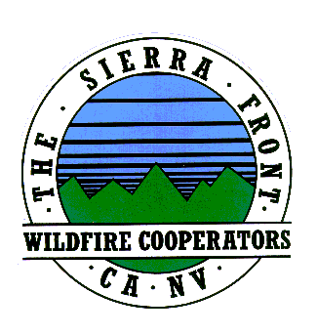
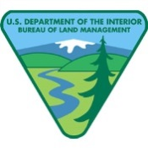
News Release
Nate Rasner Sierra Front Type 3 Team
Mark Regan
Public Information Officer
Phone: 760-647-6472
Walkerfire2015@gmail.com
August 23, 2015, Update #12 8:00 a.m.

Date Started: 8/14/2015  Cause: Human | Total Personnel: 231  Injuries/Illnesses to Date: 3
Size: 3,676 acres | Structures Threatened: 220
Percent Contained: 73%  Resources: 1 Helicopters, 0 Seats, 0 Air Tankers  6 Engines, 6 Crews, 6 Water Tenders, 4Dozers | Structures Lost: 0  Estimated Containment: 8/26/2015
Walker Fire is at 73% Containment
Lee Vining, CA: Burning approximately two miles southwest of Lee Vining the Walker Fire remains at
3,676 acres. This is a human-caused fire that is still under investigation.

Smoke in the area is the result of several wildfires burning throughout California. Crews continue to make progress improving containment lines as well as mop up, which includes extinguishing interior hot spots to ensure that the fire does not re-ignite.

A BAER (burned area emergency response team) is on the fire to work on fire suppression repair.

Anyone who was in the Walker Lake area on August 14, 2015, is asked to call 760-920-7149 with any information that may pertain to the fire.

For the safety of our firefighters, effective air operations and continued containment efforts, please keep drones away from the Walker Fire and near heliports.
Closures and Evacuations:
- PLEASE NOTE: The Walker Lake Road (1N17), the Parker Lake Rd. (1S25), the Upper Horse Meadows Rd. (1N16), and the Gibbs Road (1N18) are closed for fire operations and public safety. All of these roads are accessed via the northern end of the June Lake Loop. All spur roads off of these roads are also closed. The trail to Mono Pass (trailhead is at Walker Lake) is closed.

- Walker Lake “Fishing Camp” has been evacuated and is closed to the public.
- Campgrounds in the Lower Lee Vining Canyon will reopen tomorrow. These areas include Lower Lee Vining, Moraine, Boulder, and Big Bend Campgrounds. Aspen Grove will continue to be closed throughout the week.
Approximately 231 firefighters are on scene as well as numerous aircraft, dozers, and engines. Resources from Mono County, local fire departments, Cal Fire, neighboring forests, BLM Bishop Field Office, and the Mono County Sheriff’s Office are assigned. For more information on the Walker Fire you can go to the following sites: Inciweb: http://inciweb.nwcg.gov/incident/4515/
Facebook: https://www.facebook.com/inyonfhttps://www.facebook.com/pages/Mono-County-Sheriffs-Office/597961140216123

