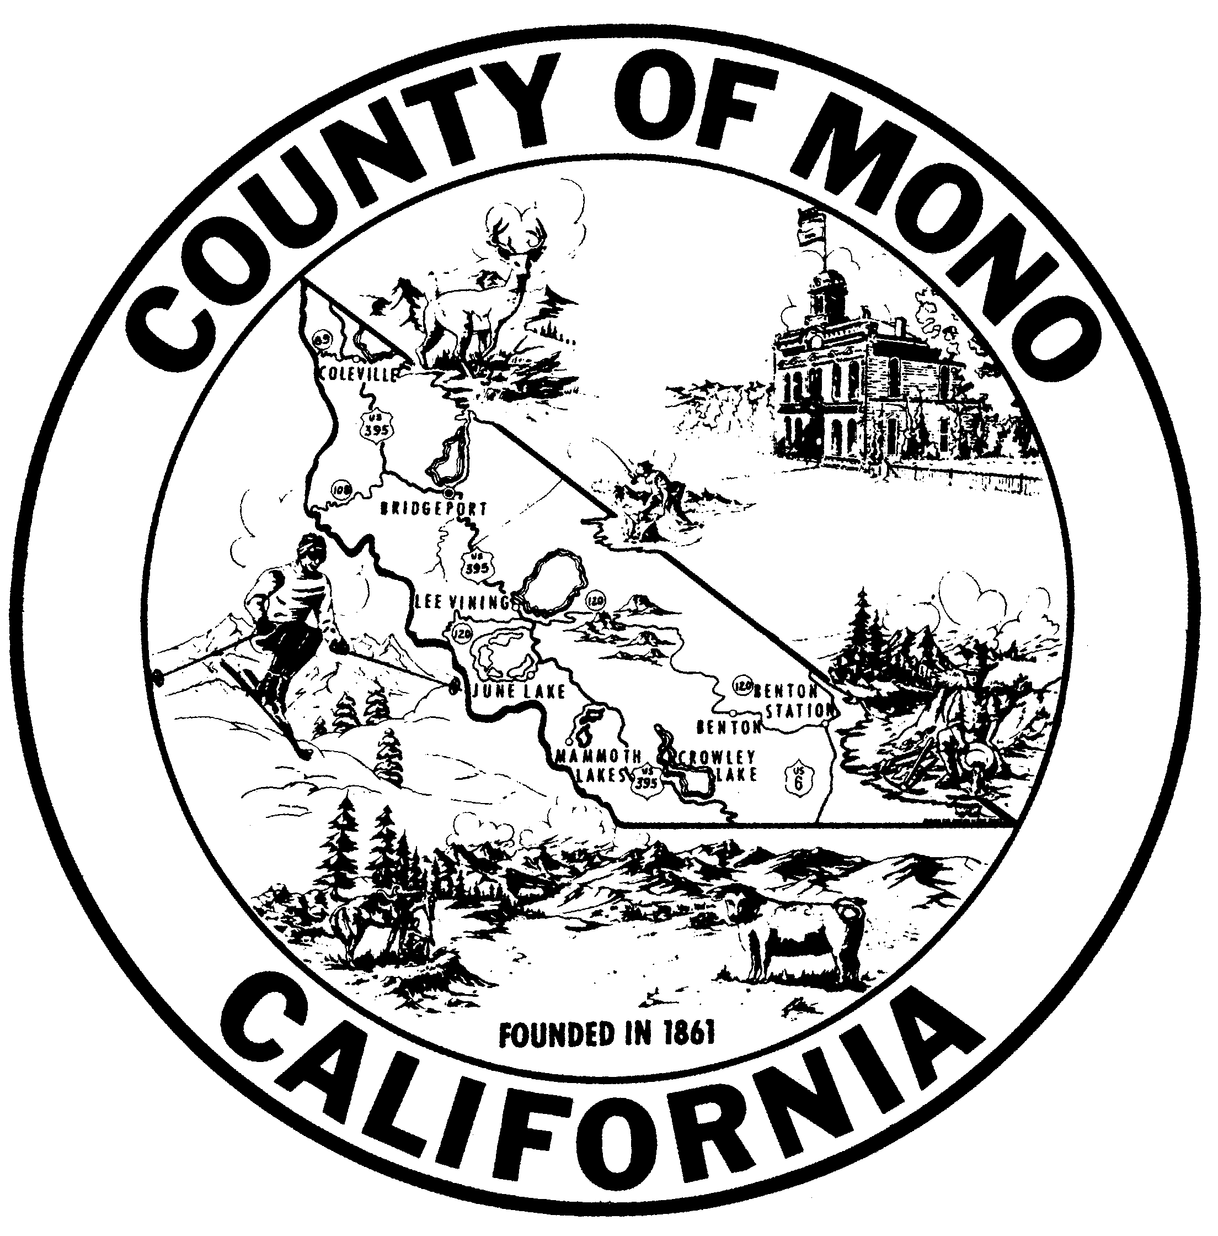

R19-__

A RESOLUTION OF THE MONO COUNTY BOARD OF SUPERVISORS
APPROVING THE MAMMOTH LAKES FIRE PROTECTION
DISTRICT’S REQUEST TO CONSOLIDATE ITS SPECIAL
ELECTION WITH THE MARCH 3, 2020,
PRESIDENTIAL PRIMARY ELECTION

WHEREAS, the Mammoth Lakes Fire Protection District has called a Special Election to be held on March 3, 2020, to submit to the voters of the Mammoth Lakes Fire Protection District the adoption of a proposed ordinance imposing a special tax for fire protection services within the district; and

WHEREAS, the Mammoth Lakes Fire Protection District has requested that the Special Election be consolidated with the March 3, 2020, Presidential Primary Election; and

WHEREAS, it is desirable that the Special Election be consolidated with the Presidential Primary Election to be held on the same date, and that within the district, the precincts, polling places and election officers of the two elections be the same, and that the Mono County Election Division canvass the returns of the Special Election, and that the election be held in all respects as if there were only one election; and

WHEREAS, the Board of Supervisors is requested to consent and agree to the consolidation of a Special Election with the Presidential Primary Election, and issue instructions to the Mono County Elections Division to take any and all steps necessary for the holding of the consolidated election.

NOW, THEREFORE, BE IT RESOLVED by the Mono County Board of Supervisors as follows:

SECTION 1: Pursuant to §10400, et seq., of the California Elections Code, the Mono County Board of Supervisors consents and hereby orders the consolidation of the Mammoth Lakes Fire Protection District’s Special Election with the Presidential Primary Election on Tuesday, March 3, 2020, for the purpose of submitting to the voters of the Mammoth Lakes Fire Protection District the adoption of a proposed ordinance imposing a special tax for fire protection services within the district.

SECTION 2: The Mono County Elections Division is instructed to take any and all steps necessary for the holding of the consolidated election. The election shall be held in all respects as if there were only one election and shall be in form and content as required by law.

SECTION 3: The Mono County Elections Division is authorized to canvass the returns of the Special Election.

SECTION 4: Pursuant to California Elections Code § 10002, the Mono County Elections Division will bill the Mammoth Lakes Fire Protection District for any costs incurred because of this consolidation and shall be reimbursed by the Mammoth Lakes Fire Protection District accordingly.

PASSED, APPROVED and ADOPTED this 19th day of November 2019, by the following vote, to wit:

AYES:
NOES:
ABSENT:
ABSTAIN:

______________________________
John Peters, Chair
Mono County Board of Supervisors

ATTEST: APPROVED AS TO FORM:

_________________________ ______________________________
Clerk of the Board County Counsel

