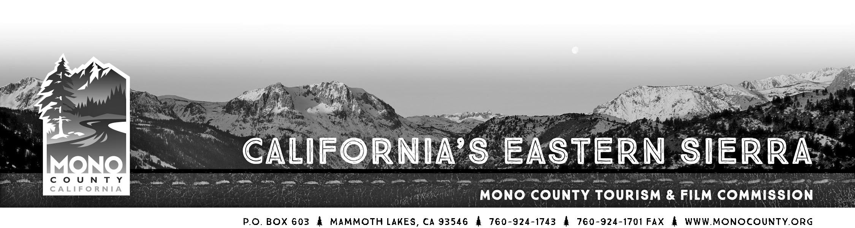

MINUTES
MEETING of Tuesday, October 27, 2015 - 10:00am Twin Lakes Annex Conference Room
199 Twin Lakes Road Bridgeport, CA 93517

Present: Michael Vanderhurst, Steve Morrison, Chris Long, Geoff McQuilkin, Jimmy Little
Absent: Jennifer Roeser, Andrew Jones
Staff: Alicia Vennos, Liz Grans, Jeff Simpson
Other: Craig Schmidt (Mammoth Lakes Chamber of Commerce)

- Call to Order. The meeting was called to order at 10:04am by Commissioner Little.

- Introductions and announcements.

- Opportunity for the Public to Address the Commission on items of interest of the public which are within the subject matter jurisdiction of the Commission. (Speakers may be limited in speaking time depending upon the press of business and number of persons wishing to address the Commission.)

- Approval of the Minutes of September 22, 2015 regular meeting. MOTION MADE BY VANDERHURST, SECONDED BY MORRISON, TO APPROVE THE MINUTES OF THE SEPTEMBER 22, 2015 MEETING. APPROVED 5-0, NO ABSTENTIONS.

- June Lake Loop Performing Arts Association: Presentation, Mike Ginther/Bonnie Tamblyn
ACTION: Discuss and consider approval of proposed plan.
Mr. Ginther and Ms. Tambyln joined the meeting via conference call and presented information to the Commission regarding their efforts to hold and promote the event which has been rescheduled to October of 2016. A new website has been created, a small “salon” writing workshop was held in June Lake on October 23rd kicking off a series that will be continued online and hopefully create a community of writers that will be interested in attending the event next fall. At the 10/23 workshop they connected with a June Lake resident interested in helping with the event. Discussion on how to maintain the relationship with the County and honor the commitments made through the Community Event Marking Fund contract were discussed and a motion was made.
MOTION MADE BY VANDERHURST, SECONDED BY MCQUILKIN, TO HOLD JLLOOPAA HARMLESS FOR THE $2,000 SPENT ON MARKETING IN 2015 WITH THE UNDERSTANDING THAT THE EVENT WILL BE HELD IN 2016, WITH CONTINUED USE OF THE MONO COUNTY LOGO AND TOURISM PHONE NUMBER IN MARKETING EFFORTS, AND TO NULLIFY THE $1,000 REMAINING ON THE 2015 CONTRACT. APPROVED 5-0, NO ABSTENTIONS.

- Business Retention & Expansion Survey/Peak Performance Program – Craig Schmidt, Mammoth Lakes Chamber of
Commerce.
Mr. Schmidt updated the Commission on two new programs that, in partnership with Mono County, were awarded $50,000 from the USDA Rural Business Entrepreneurial Grant: the Technical Assistance Program and the Peak Performance Program (PPP). The Tech Asst. program is up and running and they are continuing to certify consultants. The PPP, a web-based customer service training program from which participants earn a certificate, is being developed to start in spring 2016. The PPP program will also be used in the Mono County Office of Education’s “Hospitality Career Pathways” curriculum. The Chamber is also still working on the Business Retention and Expansion survey, with spring 2016 as a goal start time, and continuing to host monthly “Business After Hours” and “Power Lunch” events. Commission Vanderhurst added that the October Power Lunch had an excellent presentation on Reno’s reinvention as a travel destination from Carl Ribaudo of SMG Consulting. The presentation PDF is on the Chamber website. Mr. Schmidt also commented that he is working to bring all chambers in Mono County together for a meeting and continue those on a regular basis.

- Community Event Marketing Fund – Review Draft 2016 Program Application
ACTION: Discuss and consider approval of program parameters.

- Historical Societies Grant Program – Review Draft 2016 Program Application
ACTION: Discuss and consider approval of program parameters.

- Monthly Financial/Budget Report. Staff is still working on tweaking the reporting system, but expenses are on track thus far.

- Commissioner Reports.

- Economic Development Update. Staff is working with On Point Production on a video series of testimonials from businesses throughout Mono County. The series will be used as an inspirational piece for people to move their business, open a new business, or purchase a business in Mono County. Staff are also working with Mono County IT staff and the Mammoth Lakes Chamber on creating some type of incubator/shared office space.

- Fisheries Commission Report. Mr. Simpson reported that the Fisheries Commission is working on a new regulation at Rush Creek to protect brown trout during spawning. Also, if approved, brown trout diploids, that can reproduce, would be stocked in approved bodies of water next year. Still under consideration is the state-wide change to a year-round fishing season, and catch-and-release would only be enforced during spawning.

- Film Commission Update. Staff reported that there is a new Lifetime indie feature with a crew of 30 that will be filming for 10 days in Bridgeport, spending roughly $75,000 in the area. A major vehicle commercial is filming mid-November which will be a huge economic impact; a crew of 100 spending seven nights in Mammoth Lakes. Another indie film is planning on filming for one day in Bridgeport on Nov. 13th. Ms. Vennos added that she and Commissioner Morrison attended and networked at the COLA awards in LA earlier in October.

- 2016 Commission Meeting Schedule.
ACTION: Review and approve.
MOTION MADE BY VANDERHURST, SECONDED BY MORRISON, TO APPROVE THE 2016 MEETING SCHEDULE. APPROVED 5-0, NO ABSTENTIONS.

- New Tourism Website Development – Progress Report. Simpleview’s wireframe for the new site has been approved; next step is a review of design elements.

- Project Status Update:
  - Motor Touring Guide/2016 Visitor Guide. The 2016 Visitor Guide will have an additional 16 pages. Additional content may include more information on museums and historical sites, sample itineraries, OHV information, and perhaps more information on some of the County’s main attractions. Despite the cost of the additional pages, advertising fees will stay the same, and sales are off to a great start.
  - Public Relations: Staff gave a brief update on recent articles and PR efforts.
  - Advertising/Social Media/E-Newsletter: Staff gave a brief report.

- Call for Agenda items for next regular meeting.

- Adjourn the meeting and reconvene in regular session on November 24, 2015 at the Mono County Board of Supervisors Room, third floor of the Sierra Center Mall, 452 Old Mammoth Rd., Mammoth Lakes, CA 93546.0

