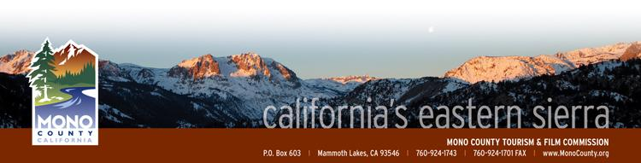

Mono County Tourism/Film Commission

Post Office Box 603
Mammoth Lakes CA 93546
760.924.1743 * 760.924.1697 (fax)
MonoCounty.org

Amended AGENDA

SPECIAL MEETING of WEDNESDAY, October 22, 2014
10:00am

June Lake Community Center
90 West Granite Avenue
June Lake, CA 93529 aM
- Call to Order.

- Introductions and announcements.

- Opportunity for the Public to Address the Commission on items of interest of the public which are within the subject matter jurisdiction of the Commission. (Speakers may be limited in speaking time depending upon the press of business and number of persons wishing to address the Commission.)

- Approval of the Minutes of September 23rd, 2014 regular meeting.

- Presentation on Funding Sources for Small Business Loan Programs through Community Development Block Grants and US Department of Agriculture – Jeff Lucas, Community Development Services.

- Economic Development Strategic Plan (EDSP) Update – Alicia Vennos/Jeff Simpson.
ACTION: Discuss EDSP strategic initiatives and determine next steps for prioritization and implementation.

- Mono County Tourism & Film Commission Bylaw Review
ACTION: Discuss and determine next steps in reviewing and revising Commission scope and bylaws.
- Monthly Financial/Budget Report.

- Community Event Marketing Grant (CEMF) – 2015 Program Review.
ACTION: Discuss and approve revisions/modifications to the current CEMF program parameters, objectives, dates and application process for the 2015 grant cycle.

- Schedule of Commission Meetings for 2015 Calendar Year.
ACTION: Discuss and approve proposed 2015 schedule of regular Mono County Tourism & Film Commission meetings.

- Commissioner Reports.

- Project Update:
  - Social Media
  - Websites
  - Booking.com & Google Analytics
  - PR & Advertising
  - Travel/Fishing Consumer Trade Show Schedule
  - Film Commission

- Call for Agenda items for next regular meeting.

- Adjourn the meeting and reconvene on Wednesday, November 19, 2014, 10am at the Lee Vining Community Center.

