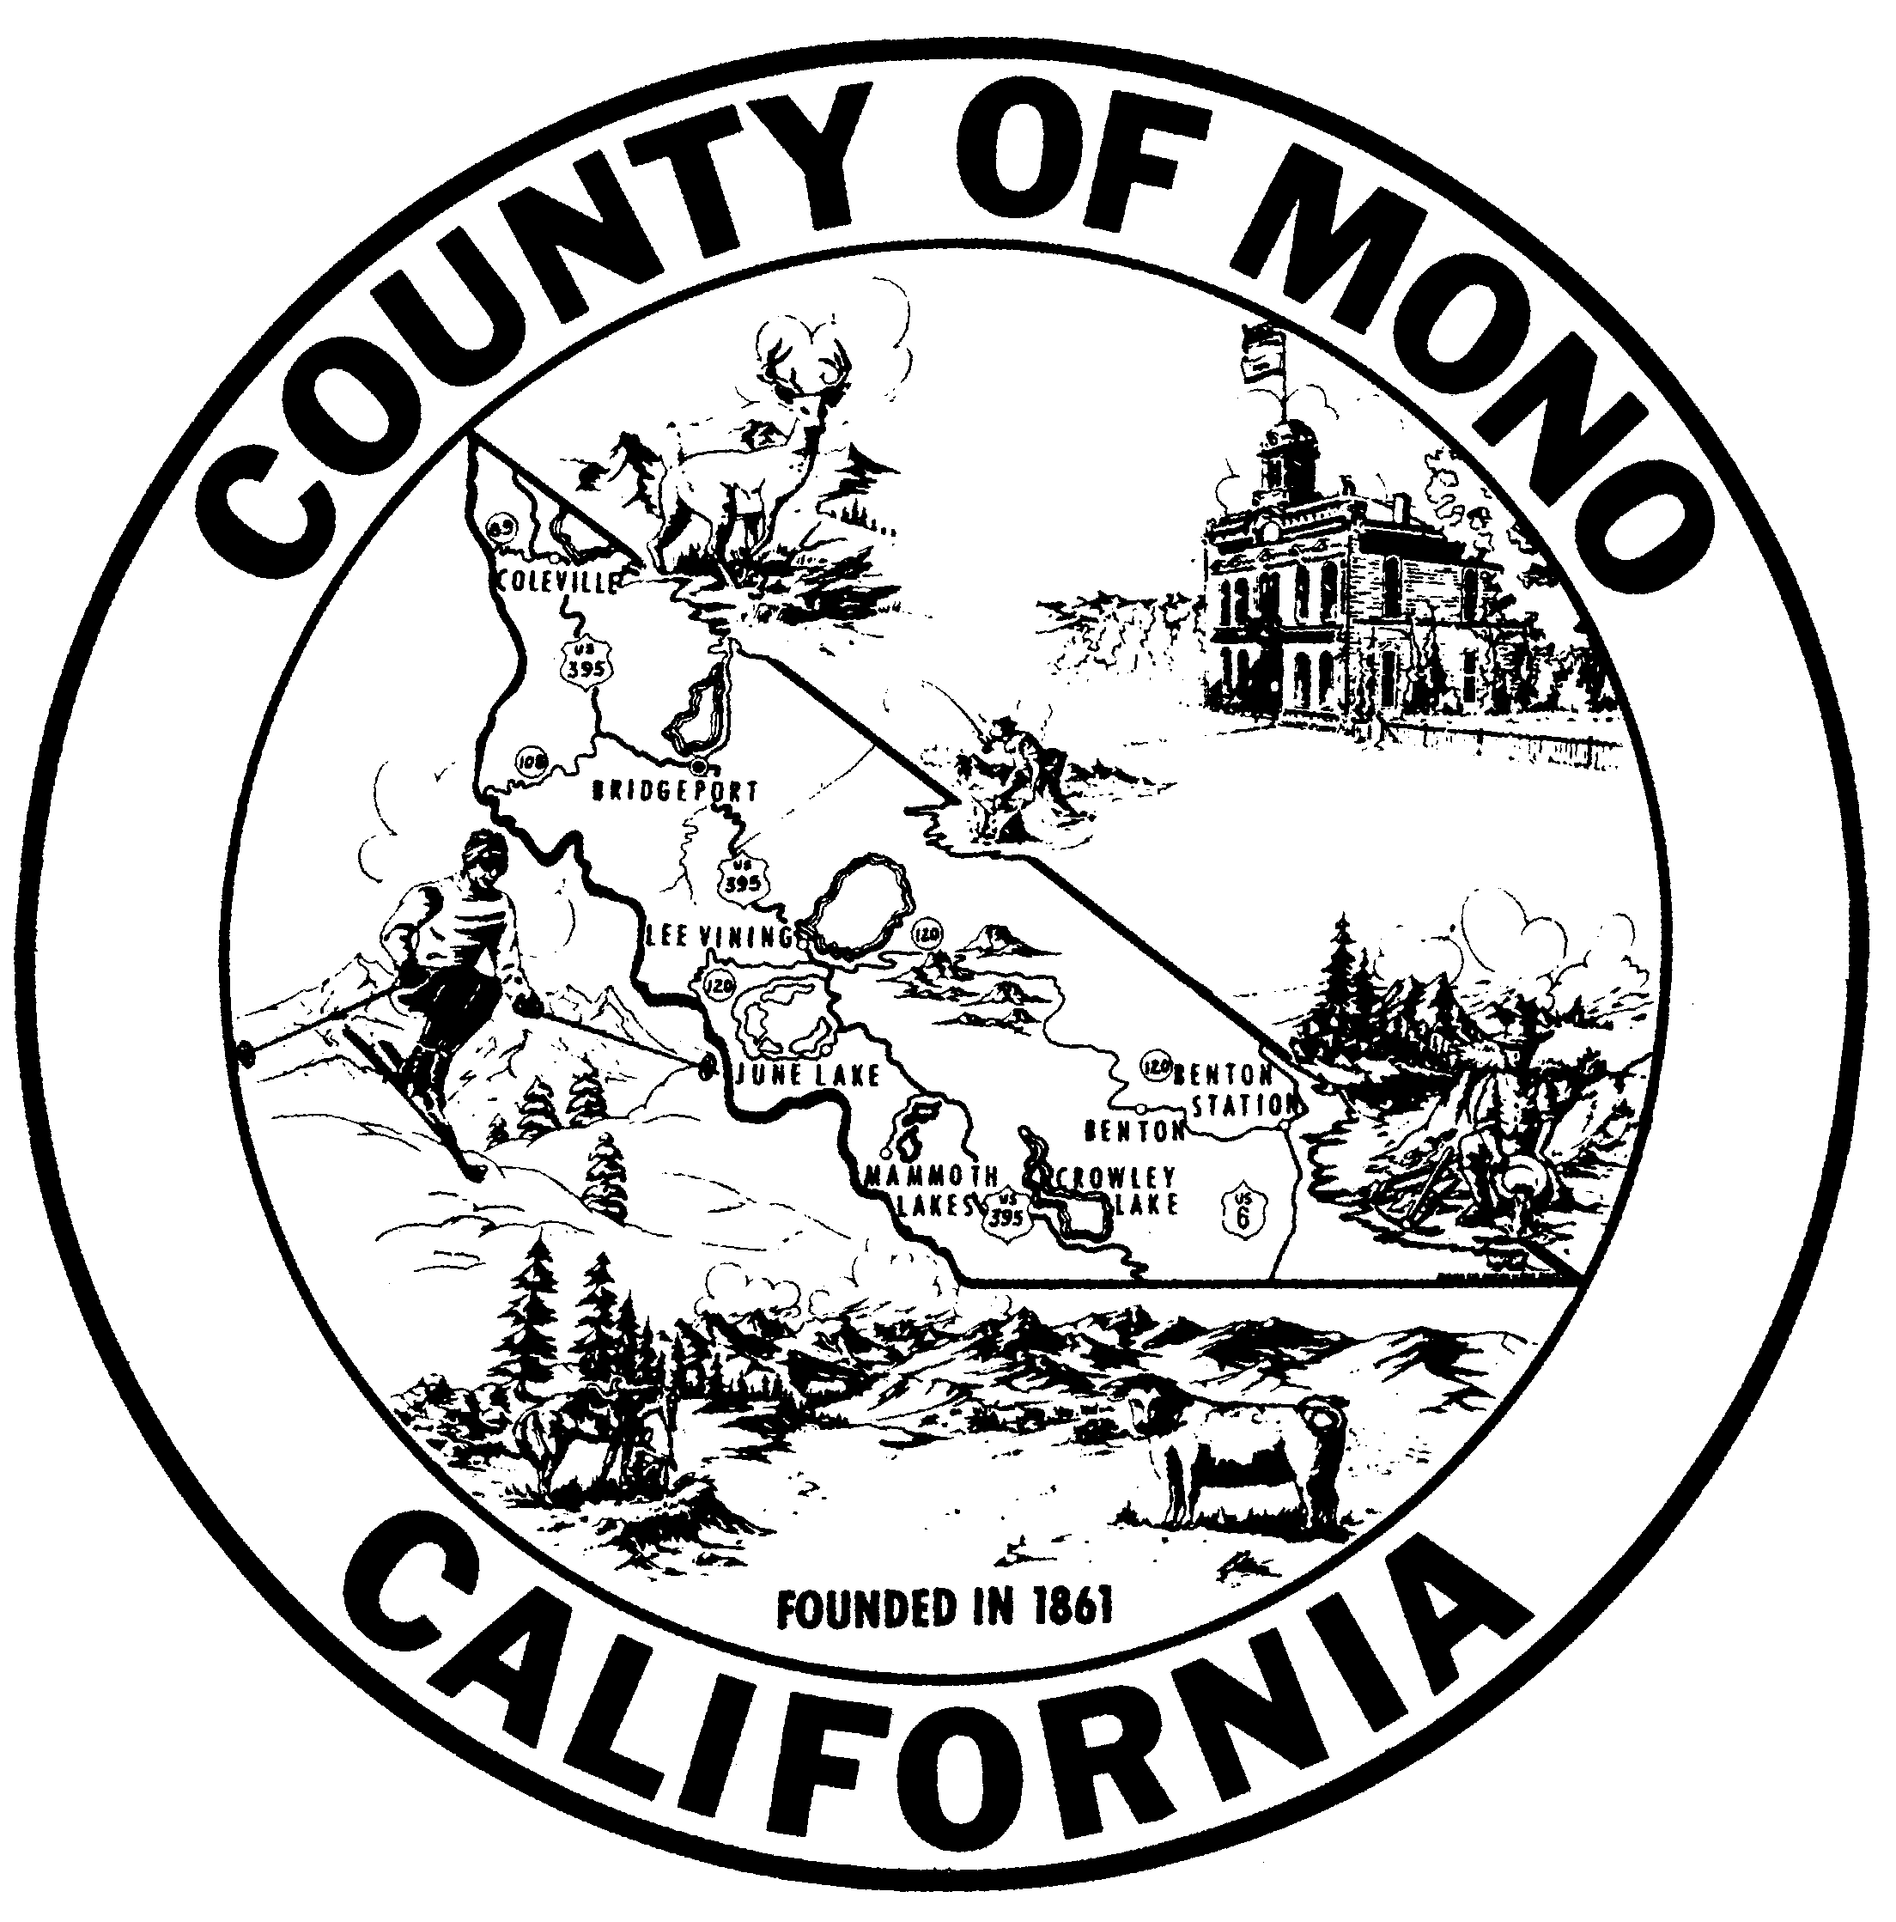

R22-__

A RESOLUTION OF THE MONO COUNTY BOARD OF SUPERVISORS
APPROVING ESSENTIAL WORKER PAY FOR SPECIFIED EMPLOYEES AS DESCRIBED IN THE AMERICAN RESCUE PLAN ACT OF 2021

WHEREAS, the Coronavirus State and Local Fiscal Recovery Funds (SLFRF), which is a part of the American Rescue Plan Act of 2021 (ARPA), provided $350 billion to state, local and Tribal governments to ensure that they have the resources needed to, among other things, maintain public services amid declines in revenue by providing premium pay to eligible workers needed to maintain continuity of operations of essential critical infrastructure sectors; and

WHEREAS, ARPA’s Local Assistance and Tribal Consistency Fund (LATCF) provided additional funding for local governments, including Mono County, which may be used to fulfill any governmental purposes, with the exception of lobbying; and

WHEREAS, local governments across California and the United States have provided essential worker pay (also referred to as “hero pay” or premium pay”) to workers engaged in providing essential government services throughout the Coronavirus pandemic; and

WHEREAS, consistent with direction and guidance provided by the SLFRF and utilizing funding provided through LATCF and other local sources, the Board of Supervisors wishes to implement “essential worker pay” for those employees of the County providing essential governmental services on behalf of the citizens of Mono County during the pandemic;

NOW, THEREFORE, THE BOARD OF SUPERVISORS OF THE COUNTY OF
MONO RESOLVES that:

SECTION ONE: Employees who were hired on or before March 4, 2020, worked at least 32 hours per week on average, without a break in service, between the dates of March 4, 2020, and February 25, 2022, and who remain employed by Mono County as of December 24, 2022, shall receive a one-time, lump sum payment of $2,500 paid from the County Treasury. This section shall not apply to elected officials.

SECTION TWO: Employees who were hired on or before March 1, 2021, who worked at least 32 hours per week on average, without a break in service, between the dates of March 1, 2021, and February 25, 2022, and who remain employed by Mono County as of December 24, 2022, but are not qualified to receive payment under Section One, shall receive a one-time, lump sum payment of $1,250 paid from the County Treasury. This section shall not apply to elected officials.

SECTION THREE: The County Administrator and Finance Director are hereby directed to take such actions as are necessary to implement the payments described herein by December 31, 2022, or as soon thereafter as is reasonable feasible.

PASSED, APPROVED and ADOPTED this 20th day of December, 2022, by the following vote, to wit:

AYES:
NOES:
ABSENT:
ABSTAIN:

_____________________________
Bob Gardner, Chair
Mono County Board of Supervisors

ATTEST: APPROVED AS TO FORM:

_________________________ _____________________________
Clerk of the Board County Counsel

