Meeting Minutes:
Behavioral Health Advisory Board Meeting

Monday August 9, 2021 from 3:00-4:30
Zoom meeting:
Link: https://monocounty.zoom.us/j/7609241741
Call in: +1 669 900 6833
Meeting ID: 760 924 1741
Attendees: Marcella R., Carolyn B., Jimmy L., Lauren P., Rolf K., Jacinda C., Robin R., Ingrid B., Connor, Lois K, Krista C., Al D., Jacob E., Iphone (Guest), Stacy C., Debbie P.
Meeting called to order at 3:03pm
- Public Comment
  - None
- Approval of minutes from June 14, 2021
  - Rolf K. – Motion to approve
    - Second to Approve – Al D.
    - Votes: Lois K., Rolf K., Carolyn B.,
    - Minutes approved!
- Behavioral Health Department Updates
  - Staff changes & upcoming audits/reports/preparation
    - Hurting for capacity – Several MCBH job openings that are a struggle to fill
  - Covid-19 updates/Civic Center opening
    - MCBH received a request to restart Coping with COVID talk series. At this time, MCBH is not sure how/who/when, but will work on getting that going again.
    - MCBH New offices in Civic Center still have no sound proofing, which will delay in-person services.
    - Mono County had a soft opening planned for this month; now delayed due to rise in COVID variant cases.
  - Community program update
    - MCBH is continuing to offer in-person programming outdoors only, and will continue to do so based on state/local guidelines and staff comfort.
    - Programming available in Walker, Bridgeport, Mammoth Lakes and Benton! All programming is listed on www.mono.ca.gov/wellness. The Sheet and Mammoth Times will include schedule of MCBH programming in their community calendars as well.
    - For more information, contact Lauren Plum: LPlum@mono.ca.gov
  - Other updates
    - MCBH is working on the Triennial Audit – its been tough and time consuming but submitting documents this week! In person audit review to happen in September.
- Quality Improvement Discussion Topic: Behavioral Health Services for Foster Youth
  - Krista Cooper from Social Services gives presentation about Resource Family Approval (RFA) (aka foster program). Please see slides at end of this document.
  - Discussion – Mentoring for Foster Youth
    - There is currently not a formal mentoring program for Foster Youth, but, there are similar services:
      - CASA program through the Court – CASA is an advocate for the child and can be a type of mentoring.
      - MCBH offers Clubhouse Live (CHL): One of Mono County's most popular Wellness Activities is Clubhouse Live, a youth program for middle school and high school students. This program is sponsored by the Mental Health Services Act (Proposition 63) and the Mono County Child Care Council. Currently operated by invitation only due to COVID-19 regulation. Please contact Sofia for more information sflores@mono.ca.gov.
      - Mono County Probation may have state monies for a mentoring program via a 3-year grant – this may be coming soon. Intended for Middle and High School aged youth as a means to reducing drug use but could easily apply to Foster Youth.
      - RK: Is there a way to get involved as a mentor where someone can just take a kid fishing or on a hike, or just be someone to talk to them?
        - Great idea –Not sure that something like that exists in Mono County right now… (Future programming? Future discussion topic?)
- Board Appointment/New Member Recruitment
  - Vote to recommend that the BOS appoint Jimmy Lee as member of BHAB
    - About Jimmy: Full time resident in Mammoth for 2+ years, part-time resident 4 years before that. Volunteered at IMACA food distribution events – currently on board for IMACA. Career background – board certified Emergency Nurse. Trained to perform psychiatric evaluations in the ER setting – that is what got him interested in Mental Health and working with challenges of lacking resources in communities. Just finished advanced nursing degree and looking forward to contributing to the community via the BHAB.
    - Motion to appoint Jimmy Lee to board: Lois K.
      - Second – Ingrid B.
      - Vote: AY - Carolyn B., Rolf K., Lois K., Al D., Ingrid B.; NAY – None.
    - BHAB will recommend the appointment of Jimmy Lee to the Mono County Board of Supervisors, as an agenda item for BOS to vote on in future meeting (probably Sept)
      - Stacy C. started this process 8/9/21 by notifying Clerk of the Board of the request; Amanda G. and Marcella R. will follow through and get forms to Jimmy L. Stay tuned for the official BOS date so we can show our support!
- Board Member Reports
  - Carolyn B: Will talk to Lauren P. about community events where we can help people get wood or electricity. CB will try to go to the Social in Benton.
  - Lois K.: Just got back from vacation; nothing to report.
  - Rolf K.: Nothing to report but want to discuss Community Trauma: the Inyo Sheriff Use of Force incident:
    - RK:Is MCBH or BHAB in a better position to start a discussion about this incident as a broader issue? Perhaps start a newspaper article that put a mental health and/or community safety perspective on this?
      - RR: I don’t know enough about the incident to speak to it. MCBH is in a process with Mono Sheriffs for Mobile Crisis for outlying areas and we are trying to figure out the ways we can get help to them quicker for calls related to Mental Health. MLPD and sheriffs call us if they have someone who needs help. This may not the be the right venue to discuss this and it may be more of a Law Enforcement (LE) point of view. I think this community conversation is more about racism and LE personal experience policing in tribal areas. The Mono County Justice Equity Diversity and Inclusion (JEDI) group is beginning to talk about this larger issue and MCBH is talking about this internally.
      - CB: Perhaps start with a letter to the Editor of a local paper. Maybe we can further discuss some action at a different time.

    - RK: UDEMY has a selection of ~18 courses on different mental health response strategies. Could MCBH work up a lending library to offer/distribute some training and resources?
      - MR: Mental Health 101 was offered by MCBH in May – this training included de-escalation of mental health calls. The event was attended by several Mono County departments and first responders from Mono and Inyo Counties.
      - RR: We want to make sure people with mental illness are understood and not stigmatized. We offer individual and community services to help with that.
      - SC: Local government perspective: The objective is to find out what happened – There is an independent investigation of Inyo Sheriff happening by the DA and BOS in which they will consider structural racism and other locally contributing factors.

  - Stacy C.: In relation to the Inyo Sheriff Use of Force incident and the greater discussion of structural racism: Mono County has created the JEDI committee.
    - With the help of an objective 3rd party (Dr. Rita Cameron Wedding) we are learning of history of structural racism and how it plays into government services we offer. All County departments are invited for representation in these trainings (including the Sheriff’s Office, regarding the specific Inyo Use of Force incident). Mono County is focusing these conversations and efforts internally at this time before the next step of going public with resources, education, training, etc. Mono County is working on building a shared vocabulary and shared library of resources and tools. Example: Racial Impact Tool (Dr. Cameron Wedding) that each department can use to guide work and services, and how it can be improved.
    - Budget [for MCBH] has been approved for FY 21-22.
      - MCBH isn’t part of the Mono County General Fund – funding is very regulated outside of BOS. MCBH provided a good update of internal restructuring and use of funds, which was unanimously approved.
      - Extra funds allocated towards housing; however, Mono County is still trying to hire a Housing Coordinator. Once hired we can program the funds set aside.
  - Al D.: Just having fun; nothing to report.
  - Ingrid B.: Not much to report. Sheriff’s Office is pretty quiet except for lots of Search and Rescue for backcountry users.
- Confirm date and adjourn to next meeting.
  - Second Monday of October is a holiday (Indigenous Peoples Day)
    - Next BHAB Meeting moved to Monday October 18th @3pm
    - Request for future agenda item (next meeting):
      - Jacinda Croissant: Harm Reduction Program Update

Meeting closed at 3:56

Resource Family Approval (RFA) Program presentation by RFA Supervisor Krista Cooper, Social Services: 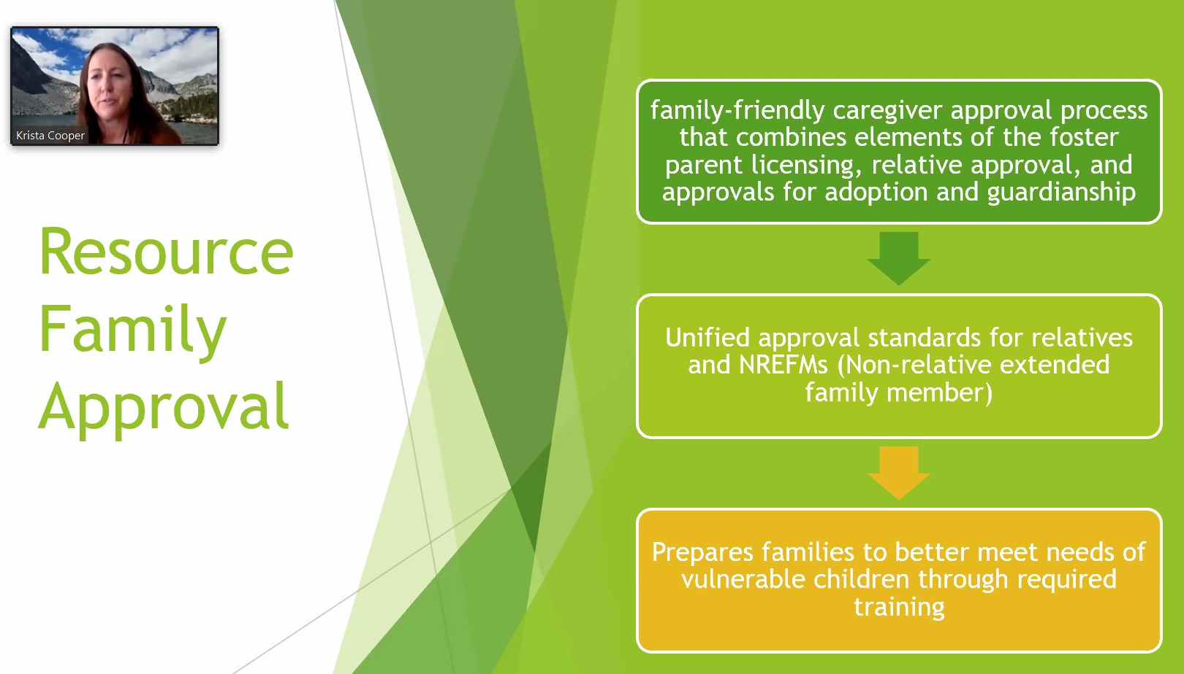
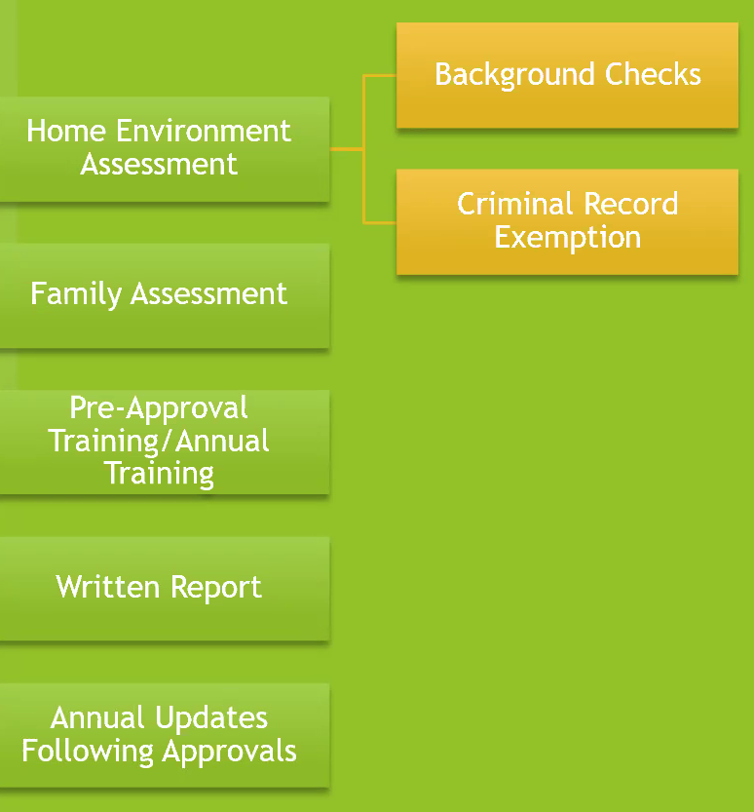

Resource Family Approval Process (above)
**Annual Updates are now Bi-Annual (every two years).

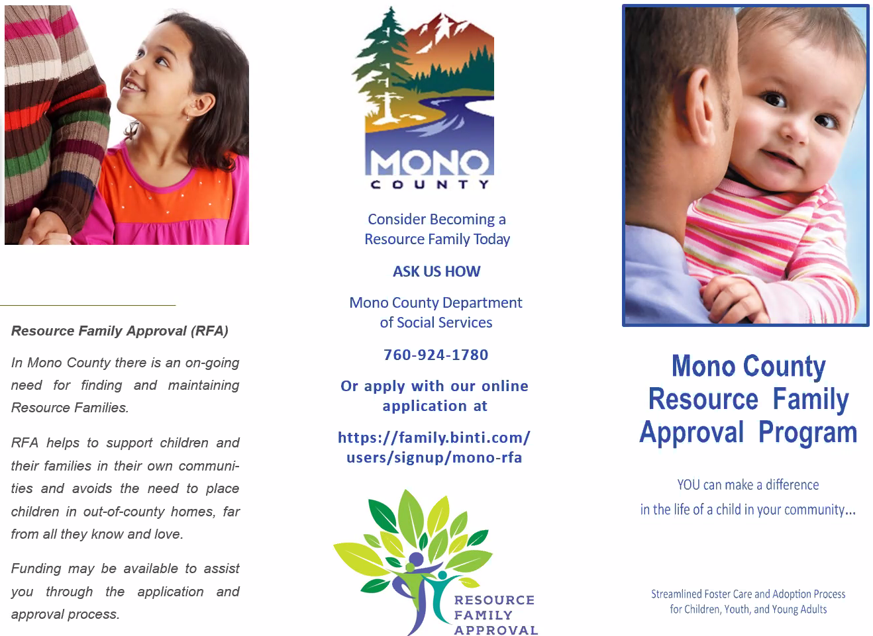
RFA brochure (above)

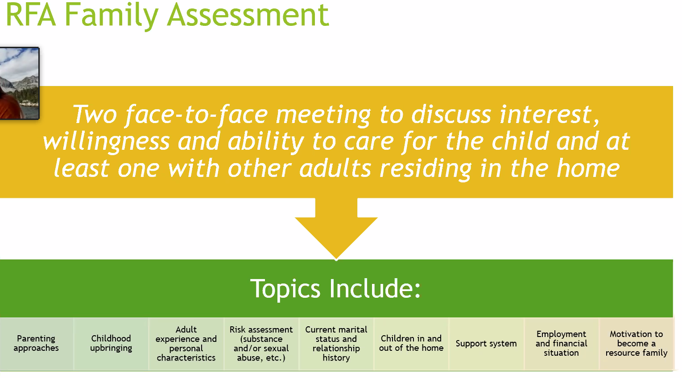
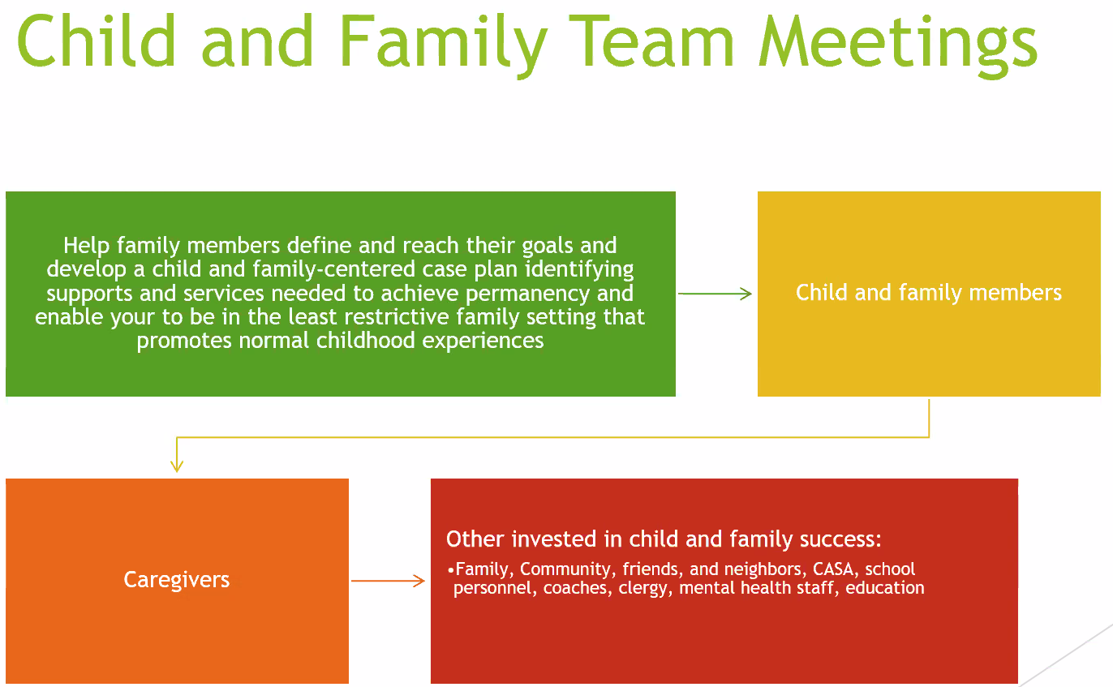

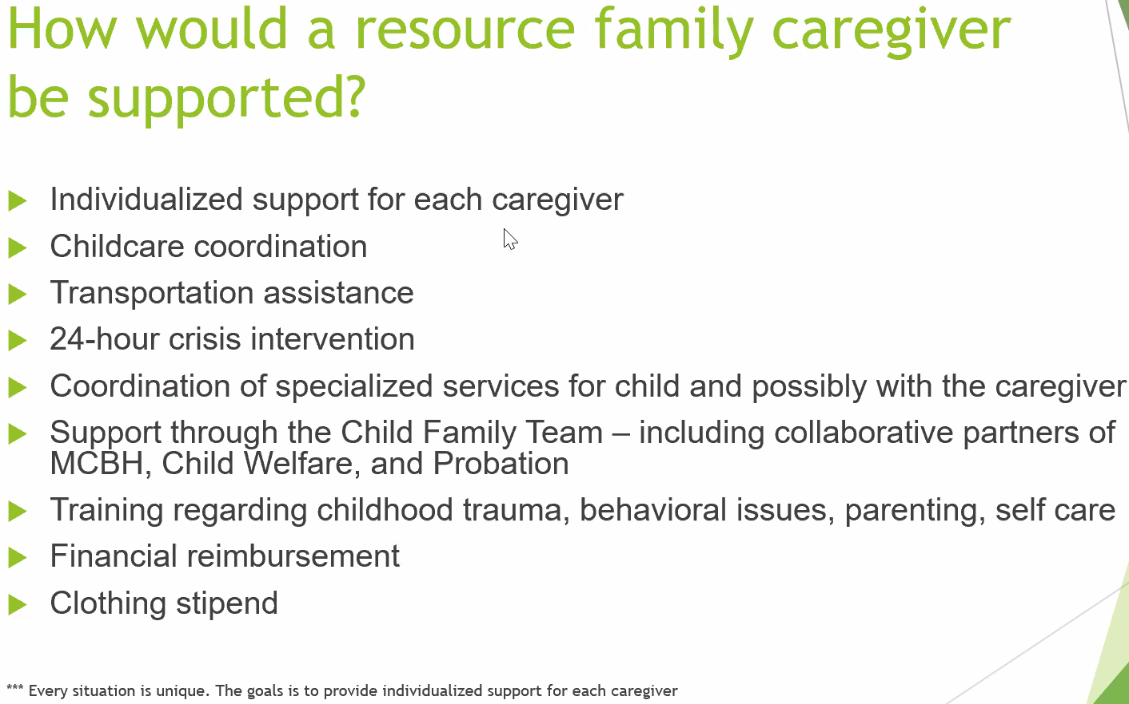

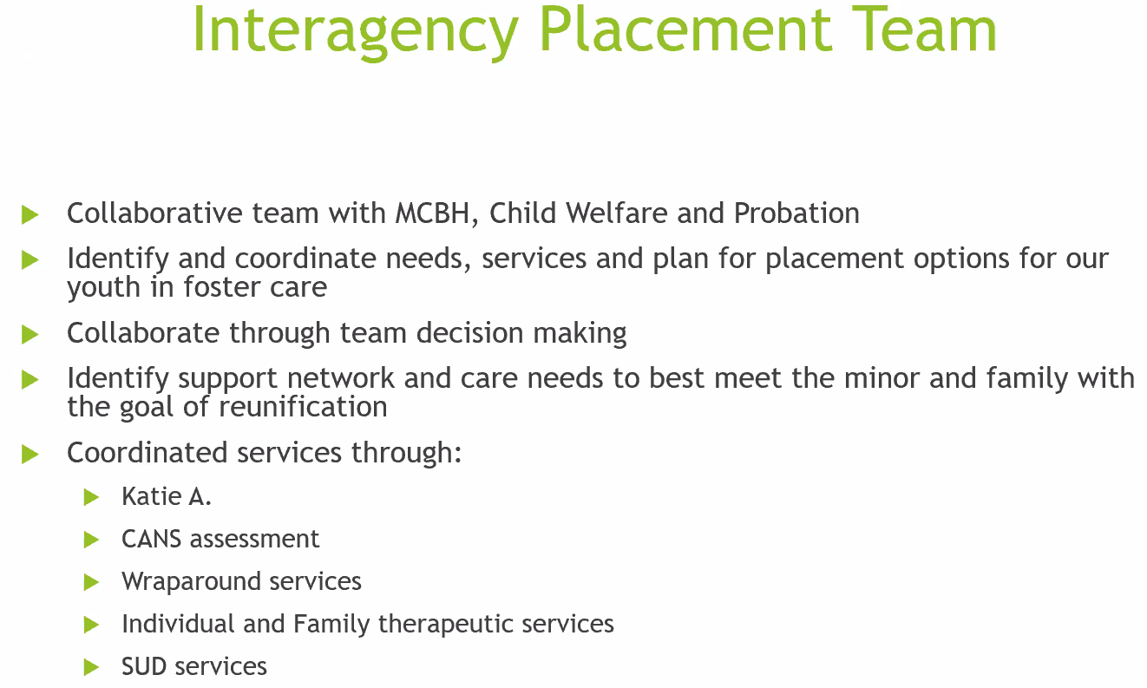

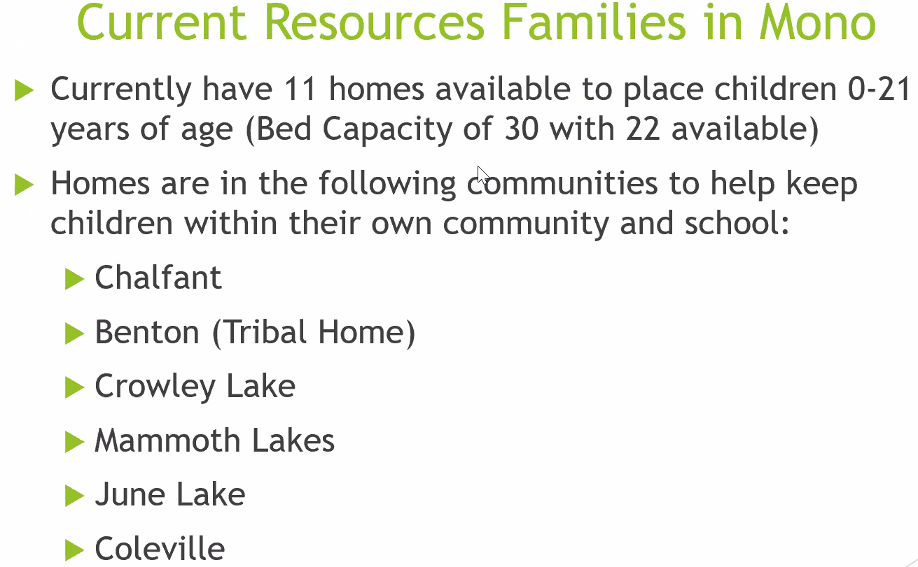

Current Resource Families in Mono (Above)
*Currently seeking Resource Families along 395 corridor between June Lake and Coleville.

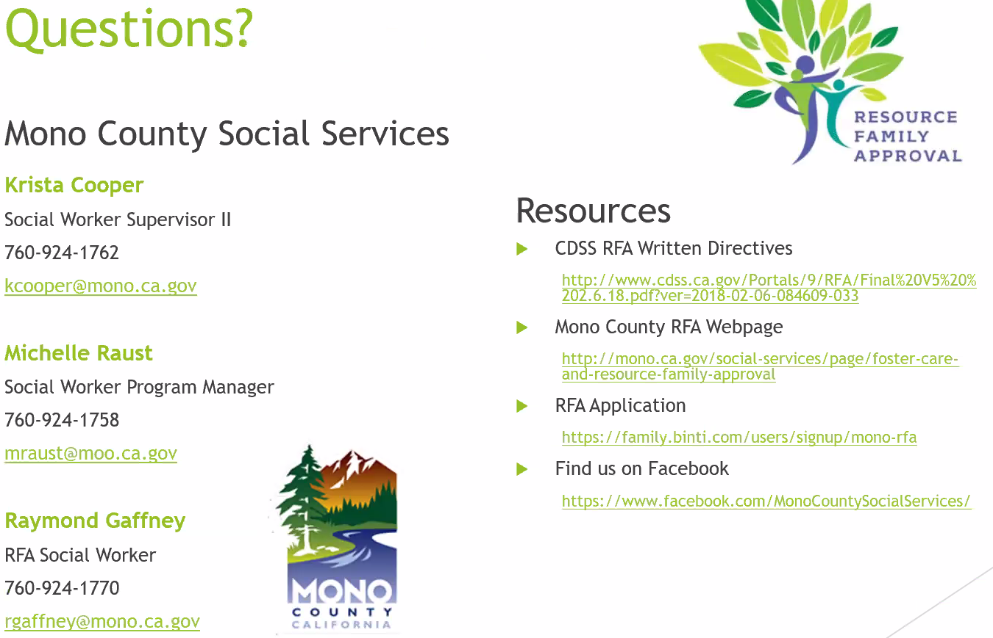
___________________________________________________________________
In compliance with the Americans with Disabilities Act, anyone who needs special assistance to attend this meeting can contact the Behavioral Health Department at 760-924-1740 within 48 hours prior to the meeting in order to ensure accessibility (see 42 USCS 12132, 28CFR 35.130). MONO COUNTY BEHAVIORAL HEALTH DEPARTMENT P. O. BOX 2619 MAMMOTH LAKES, CA 93546 (760) 924-1740 FAX: (760) 924-174

