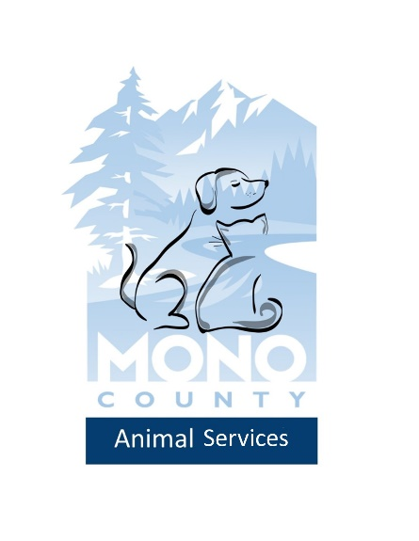
Low Cost Spay/Neuter Program
Application
Thank you for your interest in spaying or neutering your pet! This program is available to qualifying applicants to provide a discount for your pet’s spay/neuter surgery. A voucher will be issued to qualifying applicants, it will be the pet owner’s responsibility to make an appointment with the participating vet by the voucher expiration date. If you are applying for multiple animals, please complete an application for each animal.
What are the requirements for being eligible?
- Be a permanent resident of Mono County including Mammoth Lakes, or a military family based in Mono County.

- If this voucher is for your dog, you must have a current dog license either with Mono County Animal Control or with the Mammoth Lakes Police Department.

Please complete the following to the best of your knowledge. A voucher will be mailed to the address provided in this application, upon review.

Owner information
First and Last name: ____________________________________________
Physical Address: _______________________________________________
Mailing Address: ________________________________________________
City: ____________________________ Zip code:_____________________
Phone Number(s):_______________________________________________
Email: ________________________________________________________
Are you at least 18 years of age and the legal owner of this animal? _______

Pet Information
Dog_______ License # __________________
Cat_______ Feral or barn cat? _________
Breed _________________
Gender: _____________
Name ____________________________________
Age _____________________
Description/Color __________________________________________
How many litters has your pet had in the past? _____________
Has this pet ever seen a vet? _______ Who? ______________________
Does this pet have any medical conditions? ______ Please specify Below
___________________________________________________________

Pet Information
Dog_______ License # __________________
Cat_______ Feral or barn cat? _________
Breed _________________
Gender: _____________
Name ____________________________________
Age __________________________
Description/Color __________________________________________
How many litters has your pet had in the past? _____________
Has this pet ever seen a vet? _______ Who? ______________________
Does your pet have any medical conditions? _____ Please Specify Below
__________________________________________________________
Pet Information
Dog_______ License # __________________
Cat_______ Feral or barn cat? _________
Breed _________________
Gender: _____________
Name ____________________________________
Age _____________________
Description/Color __________________________________________
How many litters has your pet had in the past? _____________
Has this pet ever seen a vet? _______ Who? ______________________
Does your pet have any medical conditions? _____ Please Specify Below
__________________________________________________________
Pet Information
Dog_______ License # __________________
Cat_______ Feral or barn cat? _________
Breed _________________
Gender: _____________
Name ____________________________________
Age _____________________
Description/Color __________________________________________
How many litters has your pet had in the past? _____________
Has this pet ever seen a vet? _______ Who? ______________________
Does this pet have any medical conditions? ______ Please specify Below
___________________________________________________________

Please initial the following
_____I understand that, upon receiving my pet’s voucher, it is my responsibility to make an appointment with the participating vet before the expiration date of the voucher.
_____I understand that the surgery may cost extra if any complications arise.
_____I Understand that I must fast my pet prior to surgery.

Participating Vet
Sierra Vet Clinic
2640 W Line St, Bishop, CA 93514
(760) 873-4824

Amount Mono County Animal Services will pay toward each surgery
Dog |  | Cat
Neuter | $80 | Neuter | $50
Spay | $90 | Spay | $80

